Project Design Phase-II
Data Flow Diagram & User Stories

Date | 30 September 2026
Team ID
Project Name | AI Study Buddy API
Maximum Marks | 4 Marks
Data Flow Diagrams:
A Data Flow Diagram (DFD) is a traditional visual representation of the information flows within a system. A neat and clear DFD can depict the right amount of the system requirement graphically. It shows how data enters and leaves the system, what changes the information, and where data is stored.
Example: AI Study Buddy API
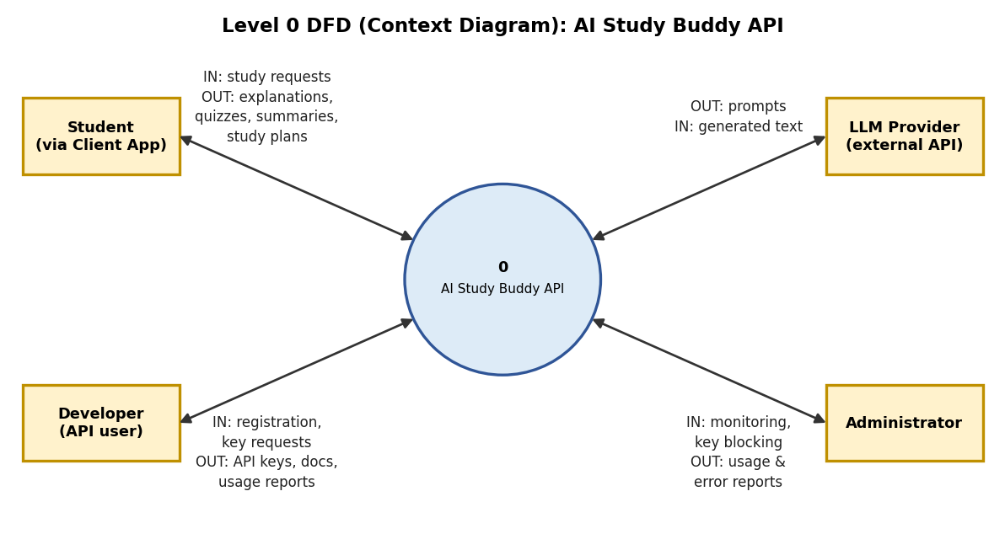
Figure 1: Level 0 DFD (context diagram)
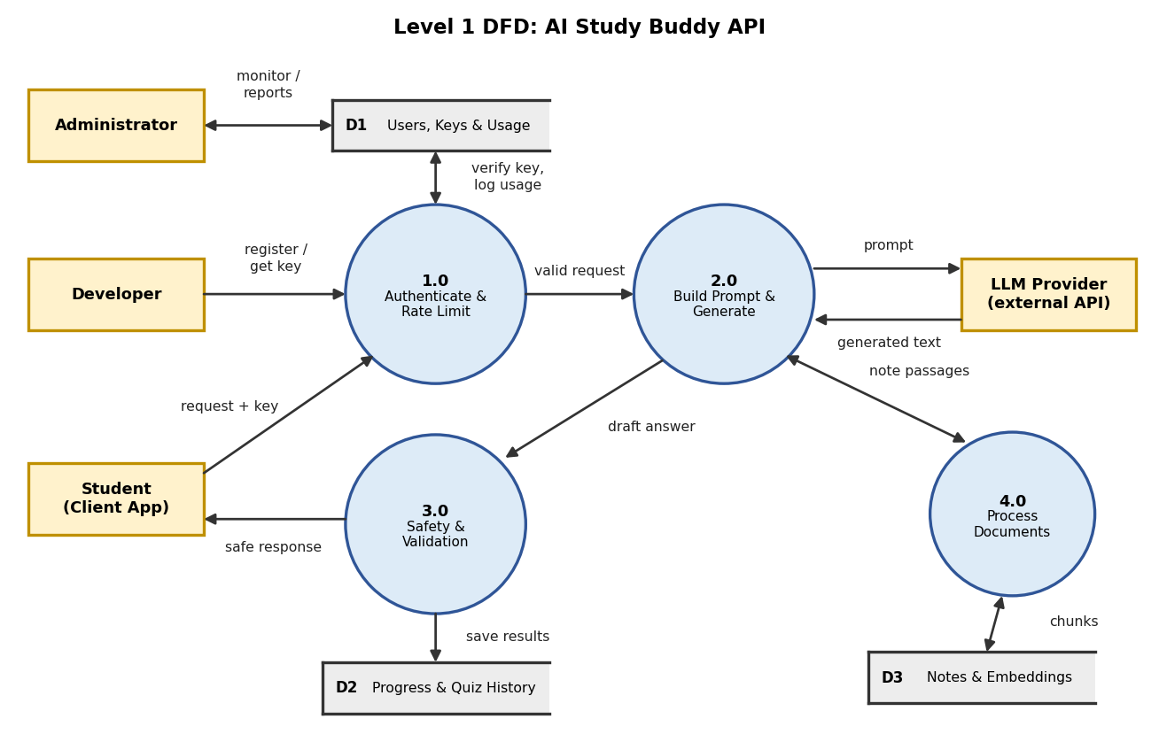
Figure 2: Level 1 DFD showing processes, data stores and external entities
Processes and data stores:
Process | Description
1.0 Authenticate & Rate Limit | Checks the API key of every request against D1, applies rate limits and logs usage. Developers register and get keys here.
2.0 Build Prompt & Generate | Chooses the level, language and prompt template for /explain, /quiz, /summarize and /plan, sends the prompt to the LLM provider and receives the generated text.
3.0 Safety & Validation | Checks the draft answer for unsafe content and correct format, saves quiz results and progress to D2, and returns the safe response to the student’s app.
4.0 Process Documents | Parses uploaded notes and PDFs, splits them into chunks, creates embeddings and stores them in D3 so answers can use the student’s own notes.

- D1 Users, Keys & Usage: users, API keys and usage logs.
- D2 Progress & Quiz History: quiz results, scores and study progress.
- D3 Notes & Embeddings: uploaded notes as text chunks and embeddings.
User Stories
Use the below template to list all the user stories for the product.
User Type | Functional Requirement (Epic) | User Story Number | User Story / Task | Acceptance criteria | Priority | Release
Student (End user) | Registration | USN-1 | As a user, I can register for the application by entering my email, password, and confirming my password. | I can create an account and access my dashboard | High | Sprint-1
Student (End user) | Login | USN-2 | As a user, I can log into the application by entering email & password. | I can log in with valid credentials; wrong credentials show an error | High | Sprint-1
Developer (API user) | API Access | USN-3 | As a developer, I can generate and manage an API key so that I can securely call the Study Buddy API. | A unique key is shown, can be revoked, and works in API calls | High | Sprint-1
Student (End user) | Explain Topics | USN-4 | As a student, I can send a topic to /explain and get a clear explanation with an example. | A valid topic returns 200 OK with an explanation and an example | High | Sprint-1
Student (End user) | Explain Topics | USN-5 | As a student, I can choose my level (beginner / intermediate / advanced) so that the explanation matches my understanding. | The advanced explanation is more detailed than the beginner one for the same topic | High | Sprint-1
Developer (API user) | API Access | USN-6 | As a developer, I get clear error messages and rate limiting so that the API is reliable and fair to use. | Wrong key returns 401, bad input 400 and too many calls 429, each with a clear message | High | Sprint-1
Developer (API user) | Documentation | USN-7 | As a developer, I can read Swagger / Postman API documentation so that I can integrate quickly. | All endpoints are listed with request and response examples | Medium | Sprint-1
Student (End user) | Practice Quizzes | USN-8 | As a student, I can generate a quiz from a topic so that I can test my understanding. | The API returns the requested number of questions with options and answers in valid JSON | High | Sprint-2
Student (End user) | Practice Quizzes | USN-9 | As a student, I receive instant feedback and explanations on my quiz answers. | Each answer is marked correct or incorrect with a short explanation | High | Sprint-2
Student (End user) | Practice Quizzes | USN-10 | As a student, I can ask for a hint instead of the full answer so that I learn by thinking. | A hint is given without revealing the full answer | Medium | Sprint-2
Student (End user) | Summarize Notes | USN-11 | As a student, I can paste text and get a short summary with key points. | The summary is shorter than the input and lists the key points | High | Sprint-2
Student (End user) | Summarize Notes | USN-12 | As a student, I can upload a PDF of notes and get a summary of its key formulas and definitions. | A PDF within the size limit is parsed and its summary lists formulas and definitions | Medium | Sprint-2
Educator (Teacher / Parent) | Safety | USN-13 | As a teacher or parent, I want unsafe or age-inappropriate content to be blocked so that students stay safe. | Unsafe requests are blocked with a polite, safe message | High | Sprint-2
Student (End user) | Study Plan | USN-14 | As a student, I can enter my exam date and topics to get a day-by-day study plan. | The plan covers every day until the exam and includes all listed topics | High | Sprint-3
Student (End user) | Study Plan | USN-15 | As a student, I can mark weak topics so that the plan gives them more time. | Weak topics get more study time in the plan | Medium | Sprint-3
Student (End user) | Progress Tracking | USN-16 | As a student, I can see my quiz history and progress over time. | Quiz history and scores are shown for each topic | Medium | Sprint-3
Student (End user) | Language Support | USN-17 | As a student, I can get explanations in my own language (for example Tamil or Hindi). | The response is returned in the selected language | Medium | Sprint-3
Student (End user) | Explain Topics | USN-18 | As a student, I get answers based on my uploaded notes with the source passage shown. | The answer uses the uploaded notes and shows the passage it came from | Medium | Sprint-3
Developer (API user) | Performance | USN-19 | As a developer, I get faster responses for common questions through caching. | Repeated common requests are served faster from the cache | Low | Sprint-3
Developer (API user) | Dashboard | USN-20 | As a developer, I can view a dashboard of my API usage, limits and errors. | The dashboard shows request count, limits and errors for my key | Medium | Sprint-4
Student (End user) | Practice Quizzes | USN-21 | As a student, I can create flashcards from my notes for quick revision. | Flashcards are created with the question on the front and the answer on the back | Low | Sprint-4
Administrator | Testing | USN-22 | As an administrator, I can review user acceptance test results and bug reports before release. | All high-severity bugs are closed before release | High | Sprint-4
Administrator | Deployment | USN-23 | As an administrator, I can deploy the API to the cloud and monitor it. | The API is reachable over HTTPS and health checks pass | High | Sprint-4
Administrator | Documentation | USN-24 | As an administrator, I can access the final project documentation and demo. | Documentation and demo are complete and reviewed | High | Sprint-4

